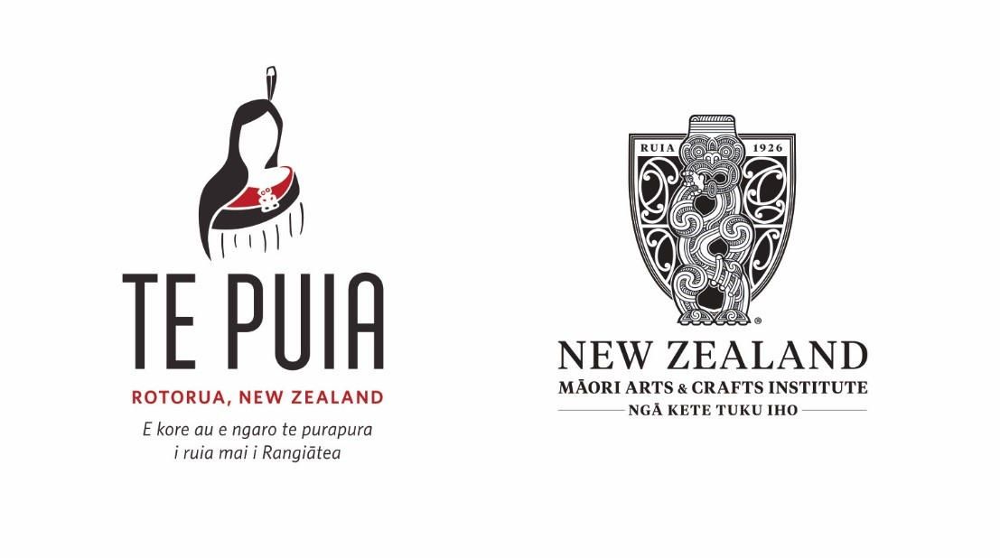

**POSITION DESCRIPTION**

________________________________________________________________________

**Kaiārahi (Guide)**

Te Puia is located in Rotorua within the Te Whakarewarewa Geothermal Reserve. Te Puia is the home of the NZ Māori Arts and Crafts Institute (NZMACI).

Te Puia is an iwi owned business that operates under the NZ Māori Arts and Crafts Vesting Act 2020. Te Puia generates most of its current revenues through visitor related activity. Te Puia has deep cultural legacies that it seeks to perpetuate, protect, and promote.

Te Puia seeks to be an employer who strongly supports the growth and development of its employees.

Te Puia strives to provide a supportive and proactive environment where employees gain satisfaction and enjoyment within their work environment and relationships while being well rewarded and recognised for their contribution.

**CONTEXT**

It is always imperative that manuhiri remain a central focus - without manuhiri Te Puia and /or NZMACI would not be able to exist.

**TE PUIA VISION**

To perpetuate excellence in Māori Arts, Crafts & Culture.

**TE PUIA VALUES**

Manaakitanga - Whanaungatanga – Kaitiakitanga

**TE PUIA PRINCIPLES**

*Teamwork:* Consistently demonstrate an unselfish commitment to working with others to create a collaborative culture.

*Passion for Customer:* A positive relationship through outstanding service with each and every interaction.

Understanding our manuhiri and what they want.

*Integrity:* Upholding the highest ethical standards and promote trust and respect.

*Excellence:* Exceeding expectations and taking intense pride in everything that we do every day.

*Leadership:* Having the courage to rise above challenges through adversity that will inspire others.

Providing a supportive, safe, and healthy workplace.

*Innovation:* Imagining what is possible and being brave. Fostering creativity that challenges constraints and drives progress.

Being adaptive and flexible.

*Guardianship:* Take care of the land, environment, and other assets for future generations.

**Position reports to:**

VE Operations/Frontline Manager

**Direct reports to position:**

Nil

**Key Relationships (Internal):**

GM Visitor Experience / HR; Te Puia Senior Management Team

**Key Relationships (External):**

Manuhiri; Escorts/Tour Guides; Tour Operators; Tour Coach Drivers.

**Purpose of position:**

* To deliver high quality, highly engaging and positive visitor experience to manuhiri.

**Primary Duties & Responsibilities**

* Greeting manuhiri with a genuine friendly smile, showing manaaki and engaging each manuhiri.
* Ensuring that each tour commences with a safety briefing, and that all manuhiri are kept safe throughout the duration of the guided experience.
* Determining if any manuhiri have physical restrictions that should be considered prior to commencement of your guided experience.
* To host and be a part of the pre-Te Pō experience whereby a short production and narration takes place, before chaperoning guests to dinner in Pātaka Kai restaurant prior to Te Pō cultural show. At the restaurant, you may be required to provide light entertainment throughout the meal, alongside other Te Pō hosting staff.
* Punctuality is paramount. Tours must start on time every time.
* Enriching our manuhiri experience by narrating and sharing our history and stories of our culture, land, and people within Te Whakarewarewa, Rotorua, and Aotearoa. This may also include, impromptu waiata and kapa acts.
* Ensuring that the information imparted is relevant and accurate.
* Taking actions to accommodate manuhiri questions or any requirements they may have.
* Try to resolve manuhiri issues or complaints as soon as possible, and in a positive and professional manner.
* Remain with your manuhiri throughout the entire duration of your guided tour.
* Continuous improvement: providing Management with constructive feedback on all information (positive & negative), that may help to improve our processes, procedures and working environment.
* Ensuring all manuhiri leave Te Puia, feeling like members of our wider whānau.
* To undertake any other responsibilities or duties as may be assigned by Management.

**Key Role Outcomes**

* Always exemplify our values of manaakitanga, whanaungatanga and kaitiakitanga.
* Adhere to all company policies and procedures at all times.
* Flexibility to undertake several tasks and functions across the organisation from time to time, as directed.

**Person Specifications**

* Must have a terrific attitude and willingness to collaborate as part of a team.
* Exceptional standard of personal presentation and hygiene at all times.
* Physically fit and able to meet the demands of the role.
* Good knowledge of Institute and Te Puia’s history and its future activities or aspirations.
* Basic knowledge in Te Reo Māori and the ability to greet all visitors in Māori with confidence; is proud to be Māori.
* The ability to speak to visitors at a level of understanding that is understandable from a manuhiri experience perspective but also from a uniquely Maori educational way, i.e., when using Maori words, explain the English meaning, or concept of it.
* Confident speaker who can express ideas with clarity and listen effectively.
* Respects other ethnic cultures and values.
* Demonstrates good time management skills. Is punctual and highly productive.
* Immediately report any hazards, accidents or near misses to your manager.
* Engaged fully in health and safety, to drive a culture of zero serious harm and safety practices within your working environment.
* Understand and assist in all critical risk rescues or incidents.
* Those with performing arts background, highly advantageous.
* Professional, yet friendly.
* Holding a restricted driver’s licence would be highly advantageous.

**Other Specifications:**

* *Creativity:* Develops innovative solutions to work related problems; identifies potential opportunities and ways to capitalize on them.
* *Relations with Others:* Is pleasant, cooperative, and gets along well with others. Keeps manager informed, reports problems promptly, and seeks guidance when needed. Develops and maintains a network of personal contacts within the organisation.
* *Self Confidence:* Asserts own point of view, even when it differs from others (e.g. manager’s), shows confidence in own skills and capacity to complete tasks; seeks necessary resources for self and/or staff to work effectively.
* *Flexibility:* Adapts approach to fit with changing conditions, tasks, responsibilities, or people
* *Customer Service Orientation:* Is courteous, patient, pleasant, and helpful with customers; shows understanding for customers’ concerns; takes actions to accommodate customer needs whenever possible.
* *Sensitivity:* Demonstrates an awareness of others’ concerns, interests, and positions, and takes into consideration the impact that decisions and plans are likely to have on them.
* *Stability:* Performs stably while under pressure or in a changing work environment. Reliable.
* *Technical Skill/Knowledge:* Demonstrates sufficient level of understanding and skill in required technical area.
* *Written Communication:* Expresses ideas in writing clearly, with correct grammar and spelling, and in a well-organised way.
* *Verbal Communication:* Express ideas orally with clarity, appropriate grammar, pace, and nonverbal gestures; listens effectively.

**Acknowledgement**

I have read and understand the duties and responsibilities required of me within this role. I will endeavour to ensure, at all times, that my actions and behaviours contribute to the success of this role and that I make a significant contribution to the growth and development of Te Puia, and that I will, at all times, promote and uphold the organisations core kaupapa, objectives and plans with integrity.

Employee: ____________________________

Signed: ­­­­­­­­­­­­­______________________________

Date: ______________________________